Friday 11th September 2026

Dear Parents/Carers,

It has been so lovely continuing to get to know your children. We are very proud of how happy and settled they are.

Our Foundation team are:
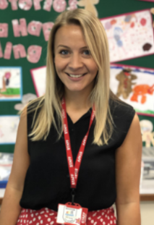
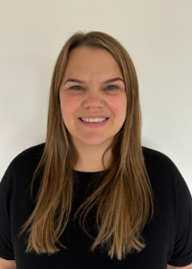
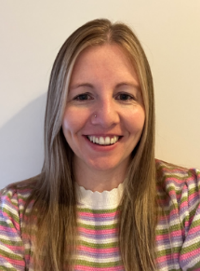
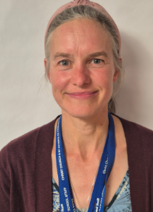

Mrs Mitchell – Wrens Mrs Bowyer – Robins Miss Moore – Robins Mrs Mount – Wrens
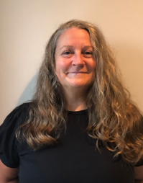
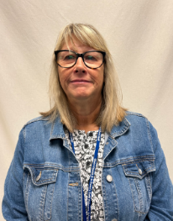

Mrs Shepherd Mrs Wardle

Mrs Mitchell is our Wrens class teacher with Mrs Mount teaching on a Tuesday. Mrs Bowyer is our Robins class teacher from Monday-Wednesday, with Miss Moore teaching on a Thursday and Friday. Mrs Shepherd and Mrs Wardle are our EYFS Teaching Assistants and help across both classes. Mrs Wardle works Monday to Friday and Mrs Shepherd works Monday to Thursday mornings and Monday and Wednesday afternoons.

Our school day is 8.40-3.15. Our classroom doors open at 8.40 and close at 8.45.

Our first topic is ‘All About Me’. Over the half term, we will be spending time finding out about your children, their needs and helping them settle into their new learning environment. We will be learning about ourselves and families – similarities and differences. We will also explore our feelings, parts of our bodies, our senses and our houses. During this half term, we will also begin phonics (Sounds-write) teaching the sounds in CVC (Consonant Vowel Consonant) words. We will also learn to explore numbers and start to subitise.

Please ensure your child has the following things in school:
- P.E. kits – plimsoles, black shorts and a white t-shirt. We will send them home when they need washing!
- A bag of spare clothes to be kept on pegs – any t-shirt and trousers/leggings/underwear/socks. This really helps us if children get wet/dirty during play or have any accidents.
- Named wellies for our outside play.
- A named water bottle every day. We encourage children to drink throughout the day. Please can they have some water in each morning to start them off.
- A warm waterproof coat each day.
- Children are welcome to bring their own fruit for snack time. Fruit is provided – a different type each day e.g. tomatoes, carrots, apples, oranges
- If your child has a packed lunch – please remember that all food needs to be 'nut free'.
Remember to name anything and everything that comes into school!! This is very important!

Please don’t allow children to bring toys in from home as they cause a lot of upset for others and can get lost.

Tapestry - We will be using an app ‘Tapestry’ that allows us to communicate with you and vice versa about what your child is learning about and how you can help at home. Please ask if you have any problems.

Reading - We will send home a wordless reading book and a sharing book each week for you to share with your children. We will also send home a little phonics pack with activity ideas and instructions. We will collect these in on a Thursday and send out new ones on a Friday.

Communication on the door – We’re always happy to chat but morning messages must be kept short as we begin teaching at 8:45. Longer conversations can happen after school. We ask you to kindly wait until all the children have been safely dismissed at the end of the day if you need us.

Thank you for all of your support, we look forward to working alongside you to give your children the best start to their school journey. We are really excited to have a wonderful year together.

Many thanks,
The EYFS Team

